Choose your network block for your new domain and a fully qualified domain name [FQDN]
The Gateway device is usually the .1 address in the block. Servers are usually .2 to .x depending on number. Managed switches are usually .254 and below.
Windows 2000 Server
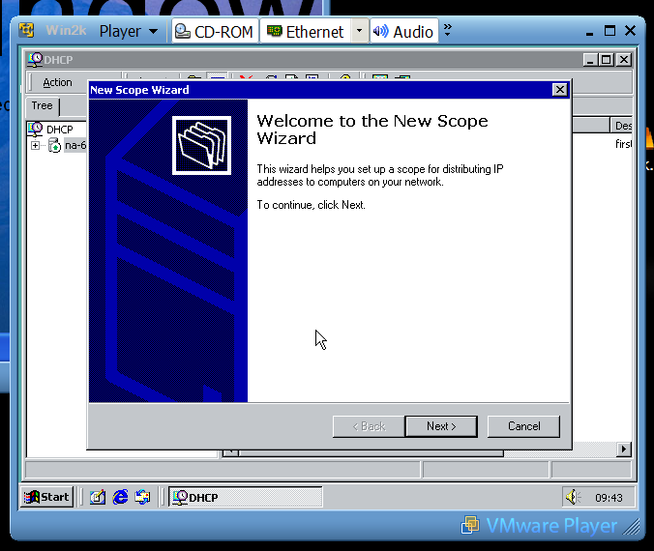
On the server configure the DHCP service with a new Scope

Give the Scope a name and description NEXT
Set clients start IP address and end IP address range and
Subnet mask NEXT
Add exclusions ie reserved static IP address for printers, gateways and
switches NEXT
Set desired lease time [typically 1 day] NEXT
Yes to configure router and DNS options NEXT
Add the router/gateway address [typically x.x.x.1] NEXT
Parent domain = pctechnicians.co.uk
Add IP address = This server’s address [Server name is used to resolve the IP address if not known, this will only work if DNS is running] NEXT
WINS Server options NEXT
Yes to activate this scope now NEXT

XP Client
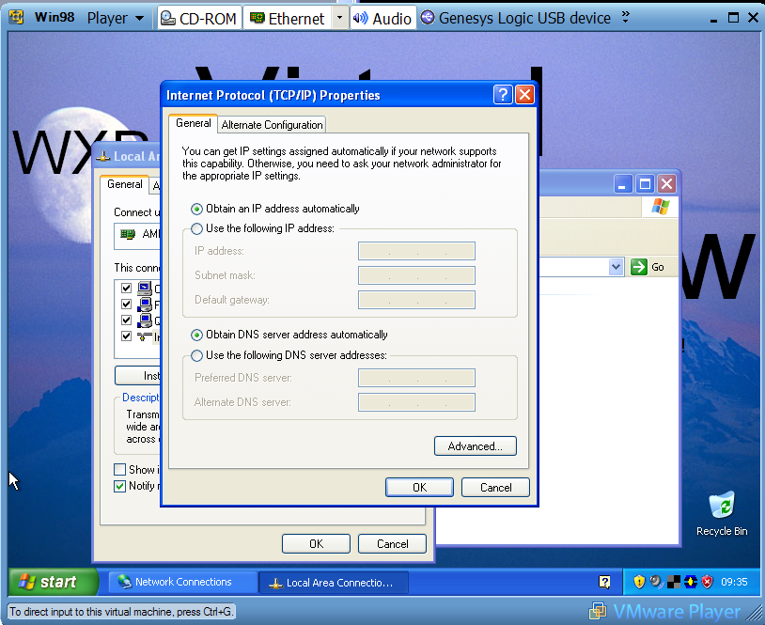
On the client workstation set TCP/IP to automatically obtain both IP and DNS.

Check your settings in DOS

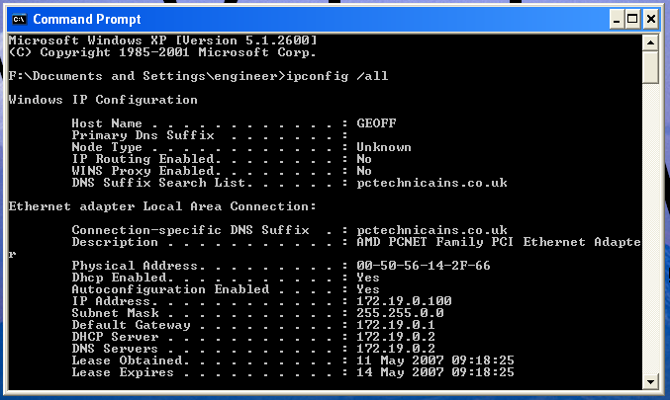

Now we have TCP/IP and DHCP configured all that’s required is DNS. You have the option to set up DNS in the Active Directory wizard so that is our next step, Active Directory – Back to the Server …

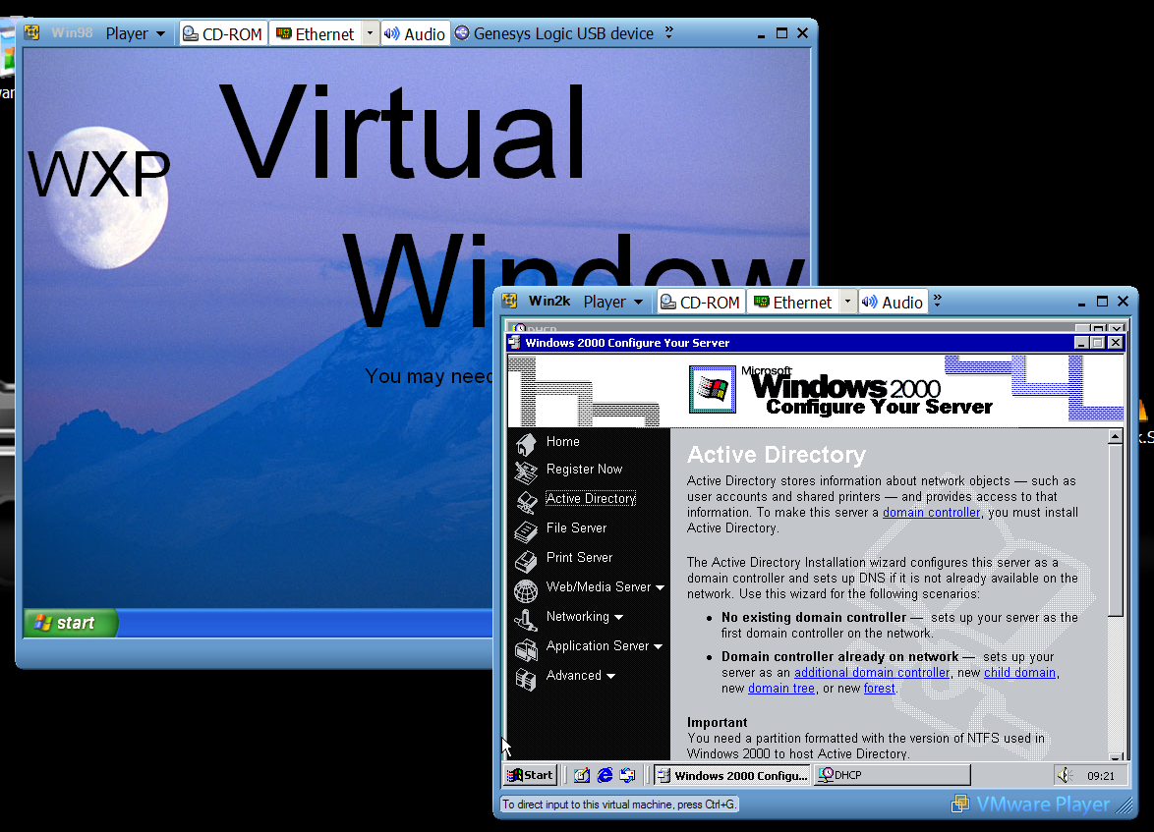
Start the Active Directory wizard NEXT
Domain Controller for a new domain NEXT
Create a new Domain Tree NEXT
Create a new Forest of Domain Trees NEXT
Full DNS = pctechnicians.co.uk NEXT
** Wait while DNS is searched **
NetBIOS name = PCTECHNICIANS NEXT
File system database and Log locations NEXT
// C:\WINNT\NTDS
Sysvol location NEXT
// C:\WINNT\SYSVOL
** Wait while DNS is searched again**
OK to ‘Cannot contact DNS…’
YES to ‘Install DNS …’ NEXT
Pre-2000 or only 2000+ clients? NEXT
Active Directory password NEXT
Summary of choices NEXT – Active Directory is built! The server will restart
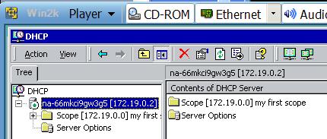
Active Director requires that the DHCP service be authorized to prevent rogue DHCP servers messing up the clients settings. When the server restarts go to the DHCP console and right click the service and select Authorize. It takes a minute or two and you need to refresh the console to see the green dot indicating a successful service start.

XP Client
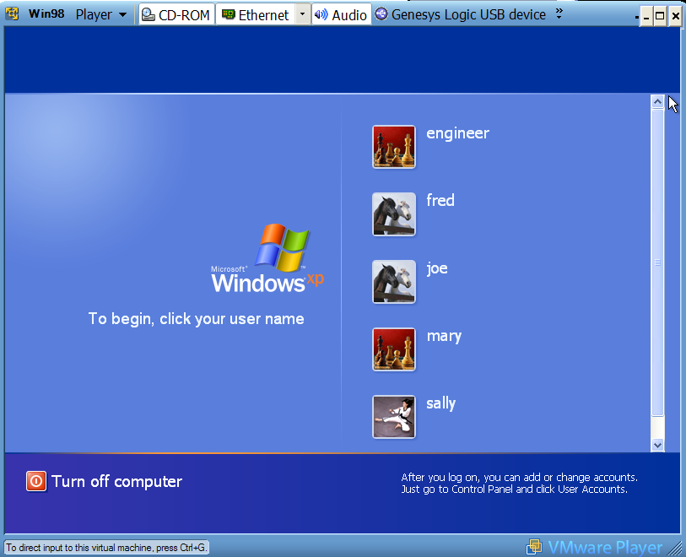
This log in screen [client] is the local machine client. When we join this workstation to the domain the workstation will change to the CTRL+ ALT + DEL client enabling a choice between local and domain logins.

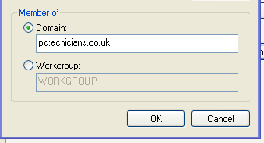
We now need to join the client to the domain. This action requires authentication by the administrator of the server. The server and the client will exchange a secret that is used for authentication and authorization for the workstation.

To join a workstation to a domain right click on My Computer, select Properties and Change. Type in the FQDN and click OK
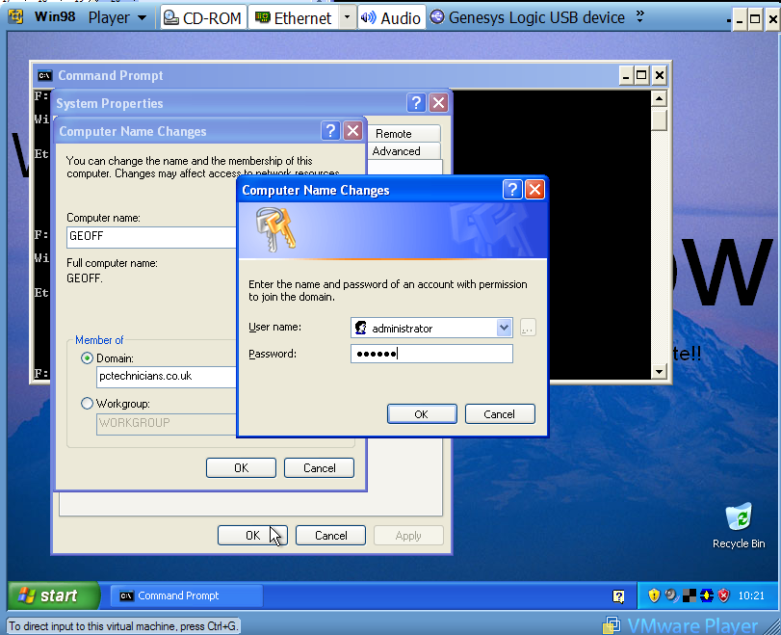
When you click OK the client will contact the server using DNS, the server will respond requesting authorization. If you provide the correct user and password for the SEVER administrator the client will join the domain and request a restart.
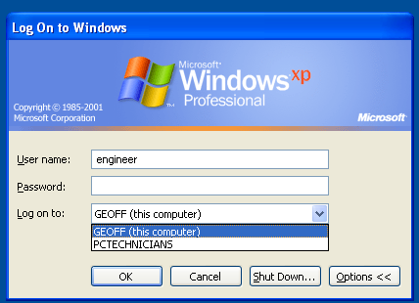
On the reboot the
workstation client
will change to enable
domain logins.

